Project « reuseit » - Cédric VONIN

Conception document of the database

(Last update on 2022, November 28th)

Table des matières

Specifications 2

Data dictionnary 3

Conceptual Data Model (CDM) 6

Logical data model (LDM) 10

# Specifications

Check out the “Specification draft.docx“ on this folder for more details.

# Data dictionnary

|  |  |  |
| --- | --- | --- |
| **Nom** | **Description** | **Type** |
| members | Members list | Entity |
| * id | Identifiant | AI |
| * username | Member’s username | Varchar(100) |
| * password | Member’s password | Varchar(100) |
| * photo | Member’s photo | Varchar(500) |
| * arrival_date | Member’s arrival date | date |
| * description | Member’s description | text |
| * status | Member’s status | int |
| Lists | Lists of tasks | Entity |
| * id | ID of the list | AI |
| Name | Name of the list | Varchar |
| * Description | Description of the list | Text |
| * Visibility | Visibility of the list | int |
| Tasks | List of tasks | Entité |
| * id | Id of task | AI |
| * id_list | List whose task is | Id |
| * name | Name of the task | varchar |
| * description | Description of the task | text |
| * importance | Importance of the task | int |
| * due_date | Due date of the task | date |
| * remind_date | Remind date of the task | date |
| * status | Status of a task | int |
| forums | List of forums | Entité |
| * id | Id of forum | AI |
| * name | Name of forum | Varchar |
| * description | Description of a forum | Tet |
| * date | Creation date of a forum | datetime |
| * status | Status date of a forum | int |
| subjects | List of subjects | Entité |
| * id | Id of a subject | AI |
| * name | Name of a subject | Varchar |
| * pinned | Is the subject pinned ? | bool |
| * status | Status of the subject | Int |
| * date | Date of the subject | Datetime |
| messages | List of messages | Entité |
| * id | Id of the message | AI |
| * date | Date of the message | Datetime |
| * content | Content of the message | Text |
| * status | Status of the message | Int |
| * ip | Ip of the message | Varchar(100) |
| Make | A member can make multiple lists, a list is made by a single member | Association |
| Members | 1,n | Cardinality |
| Lists | 1,1 | Cardinality |
| References | A task is into a single list and a list has zero to multiple tasks | Association |
| * Tasks | 1,1 | Cardinality |
| * Lists | 0,n | Cardinality |
| Treats | A subject can deal with one or zero tasks from a certain list | Association |
| * Subjects | 0,1 | Cardinality |
| * Tasks | 0,n | Cardinality |
| References | A single message appears into a single subject but subject can have multiple messages | Association |
| * Messages | 0,1 | Cardinality |
| * Subjects | 1,n | Cardinality |
| Send | A member can send 0 to n messages and a message can be sent by 1 to n members | Association |
| * Member | 0,n | Cardinality |
| * PManswers | 1,n | Cardinality |
| Recieve | A member can receive 0 to n messages and a message can be received by 0 to n members | Association |
| * IP reciever |  | Entity |
| * date |  | Entity |
| * Member | 1,n | Cardinality |
| * Private message | 1,n | Cardinality |
| Not recieve | A member can choose not to receive 0 to n messages and a private message can not be received by 1 to n members | Association |
| date |  | Entitiy |
| Member |  | 1,n |
| Private messgage |  | 1,n |
| Make | A member can blacklist 1 to n members and a member is blacklisted by 1 to n members | Association |
| * Member | 1,n | Cardinality |
| * Member | 1,1 | Cardinality |

**Gestion rules :**

* Each list of tasks belongs to a single member.
* Each task belongs to a single list.
* Each forum has 1 to n subjects
* Each subject belongs to a single forum
* Each subject is created by only one author
* Each message belongs to a certain subject
* Each message is written by a single member
* Each PM subject is designed by only one member
* Each PM answers refers to a single PM subject
* Each PM answers is written by a single member
* Each receiver information in the list of PM receivers refers to a single PM subject
* Each receiver information in the list of PM receivers tells only a perso whom receives his message
* The id of the received message id in the PMreciever row is a data from the table pmanswers
* Every id of a subject that a member stopped following is an id from the table PM subjects
* A member that not receives a certain subject whose id is [id] is identified by his id number
* Each blacklist tells who blacklists someone by indicating what is his id.
* Each blacklist is a member who blacklists another, indicated by the id of the blacklisted member.

# Conceptual Data Model (CDM)

<CDM>

<entities>

• members

- id (AI)

- username (varchar)

- password(varchar)

- photo (varchar)

- arrival_date (date)

- description (text)

- status (int)

• lists

- id AI)

- name (varchar)

- description (text)

- visibility (int)

• tasks

- id (AI)

- name (varchar)

- description (text)

- importance (int)

- due_date (date)

- remind_date (date)

- status (int)

• forums

- id (AI)

- name (varchar)

- description (text)

- date (date)

- status (int)

• subjects

- id (AI)

- name (varchar)

- pinned (int)

- status (int)

- date (date)

• messages

- Id (AI)

- date (date)

- content (text)

- status (int)

- ip (varchar)

</ entities>

<associations>

make :

- member 1,n

- list 1,1

references :

- tasks 1,1

- lists 0,n

treat :

- tasks 0,1

- subjects 0,1

List :

- forum 1,n

- subjects 1,1

references :

- message 1,1

- subjects 1,n

Send

- Member 1,n

- PrivateMessage 1,n

Recieve (ip_reciever, date)

- Member 1,n

- Private messgage 1,n

Not recieve (date)

- Member 1,n

- Private messgage 1,n

Blacklists

- Member 1,n

- Member 1,n

</associations>

</CDM>

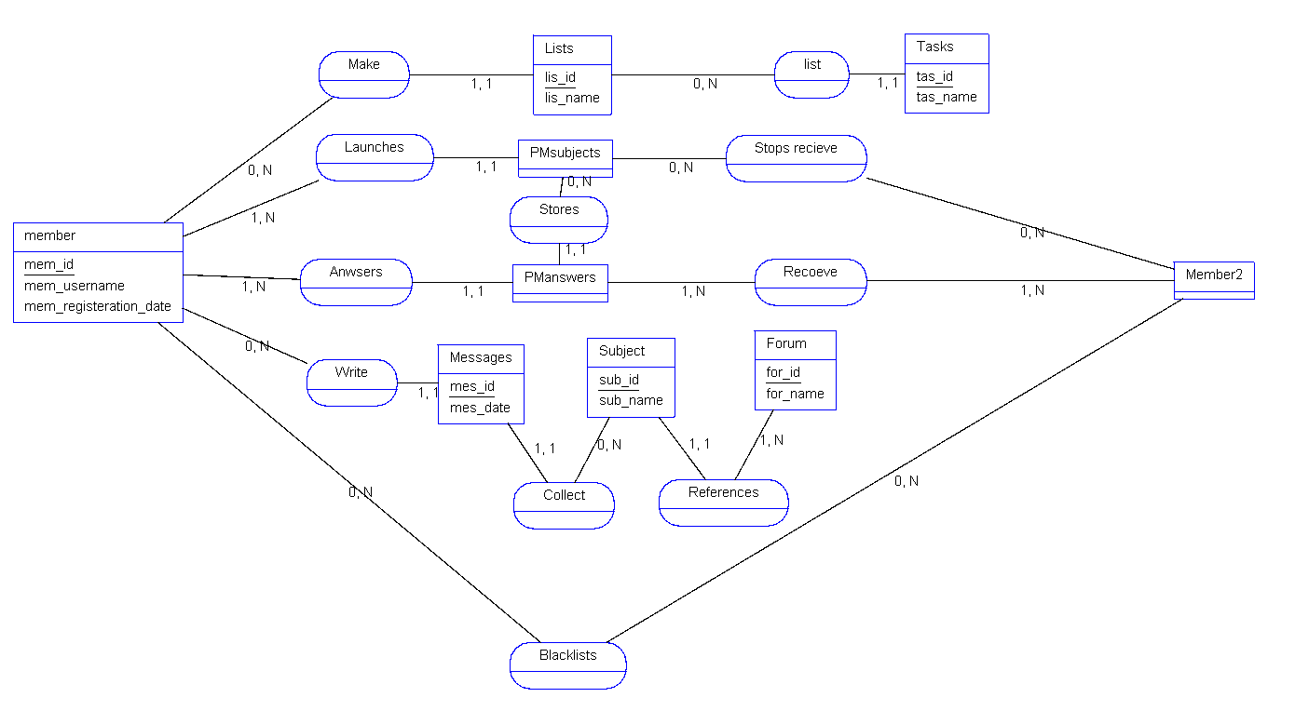

*Graphic CDM*

# Logical data model (LDM)

<LDM>

<tables>

• members

- id (AI)

- username (varchar)

- password(varchar)

- photo (varchar)

- arrival_date (date)

- description (text)

- status (int)

• lists

- id AI)

- name (varchar)

- description (text)

- visibility (int)

• tasks

- id (AI)

- id_list (FK)

- name (varchar)

- description (text)

- importance (int)

- due_date (date)

- remind_date (date)

- status (int)

• forums

- id (AI)

- name (varchar)

- description (text)

- date (date)

- status (int)

• subjects

- id (AI)

- id_forum (FK)

- task (FK or NULL)

- name (varchar)

- pinned (int)

- status (int)

- date (datetime)

• messages

- Id (AI)

- id_member (FK)

- id_subject (FK)

- content (text)

- status (int)

- date (datetime)

- ip (varchar)

• pmsubjects

- id (AI)

- id_author (FK)

- id_task (FK NULL)

- status (int)

- name (varchar)

- ip (varchar)

• pmanswers

- id (AI)

- id_pmsubject (FK)

- id_sender (FK)

- message (varchar)

- date (dateitme)

• pmrecievers

- id (AI)

- id_pmsubject (FK)

- id_answers (FK)

- id_reciever (FK)

• pmnotrecieve

- id (AI)

- id_pmsubject (FK)

- id_member (FK)

- date_stop (datetime)

• pmnotrecieve

- id (AI)

- id_member (int)

- id_blacklisted (int)

</tables>

</LDM>

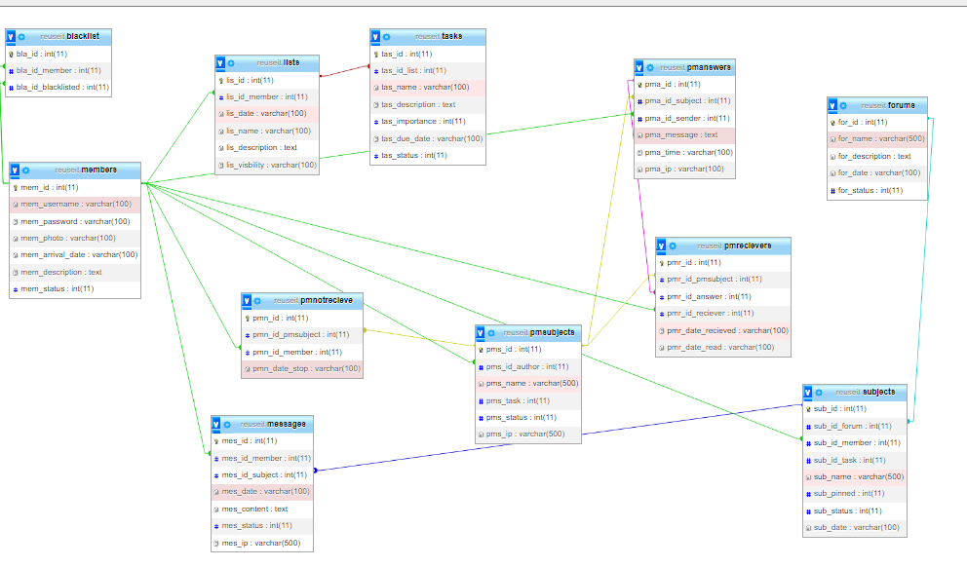

*Graphic of Logical data model*

**SQL script:** check out “reuseit.sql”